Booking Form 2024

About Holiday Forum
Holiday Forum is a gathering where anyone can come to enjoy a week of fun, faith, and fellowship on the edge of the beautiful Derbyshire Dales. Our time together is spent through having challenging theme talks, enjoyable and thought-provoking workshops, and various collective worship and fun activities.
Find out more about Holiday Forum via the website: www.urcholidayforum.org.uk.

Theme Leader

Rev Fiona Bennett

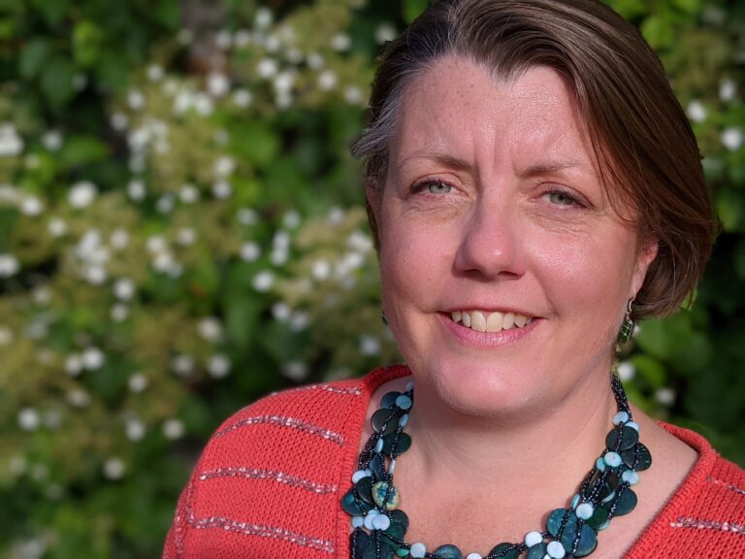

Worship Leader

Kurauone Mutimwii

Pricing
The price below is per person and includes full board accommodation, activities and workshops.
 | Full  price | Church Worker #1 | First Time Attendee #2 | Family discounts*
 |  | 20%  (Price) | 10% (Discount) | 5%  (Price) | 10%  (Price) | 15%  (Price)
Child: under 5 yrs | £60 | £48 | -£6.00 | £57.00 | £54 | £51
Child: 6-10 yrs | £170 | £136 | -£17.00 | £161 | £153 | £145
Child: 11-15 yrs | £280 | £252 | -£28.00 | £266 | £252 | £238
Student & Unemployed | £450 | N/A | N/A
Adult | £550 | £440 | -£55.00 | £523 | £495 | £468

#1 - Church Worker Discounts from the Bursary Fund may be claimed by employees (including non-stipendiary postings) of any church denomination. Acceptance of such applications is at the discretion of the Steering Group Bursary Fund administrators.
#2 – First Time Discount is an introductory discount automatically offered from the Bursary Fund to those that have not attended Holiday Forum within the last 5 years. It cannot be used if a full Bursary application is made, which will be considered on its own merits.
* In order to assist families to come to Holiday Forum, the overall price for a family will be discounted based on the numbers of children in that family attending: one child = 5%; two children = 10%; three or more children = 15% - This discount cannot be used in conjunction with Church Worker discounts but can be used in connection with First Time Attendee discounts and is provided from our Bursary Fund.
Financial Assistance
For individuals and families who may not be able to attend due to cost, Holiday Forum has a Bursary Fund which may be able to provide assistance. Applications will be considered on a case-by-case basis; and further details can be found overleaf or on the website www.urcholidayforum.org.uk.
Standing Orders/Payment Plans
If you would like to set up a Standing Order, we have given some examples of how you could pay (based on one full adult price not including the £30 deposit).
For any queries or further information, please contact bookings@urcholidayforum.org.uk
Adult Student/Unemployed
Weekly (40 weeks) £13.00 £10.50
Monthly (Over 10 Months) £52.00 £42.00
Quarterly payments £130.00 £105.00
Bank Account Name: Holiday Forum Account No.: 80462926 Sort Code: 20-73-53
Visiting Holiday Forum
Anyone who would like to attend for part of the week is welcome, and a bespoke cost can be calculated taking account of times of arrival and departure, number of meals required and accommodation needs. Please contact the Bookings Secretary for more information.

Booking Form
Details of attendees
Name(s) |  |  | Age (if under 18)
Contact details
Address:
Telephone number:
Email address:
Do you have any accessibility requirements?
If yes, please give details
Do you have any dietary requirements?
If yes, please give details
If you are coming with children, do they have any additional needs?
If yes, please give details
Is there anything else of which we need to be aware?
Do you require financial support form the Bursary fund?
Cost and payment
Total cost: |  | Standing order? |  | Yes / No
Deposit enclosed: |  | Outstanding balance:

In the event that you believe that the prices are beyond your current means please feel free to make an application to our Bursary fund for consideration. Details can be found here:
https://www.urcholidayforum.org.uk/wpsite/booking-form/cost/bursary-fund-policy/
Bookings should be made by completing the form overleaf and sending to Cathy Heath:
bookings@urcholidayforum.org.uk
020 8655 1393
2 Inglis Road, Addiscombe, Croydon. CR0 6QU

Terms and conditions
- All bookings must be made in writing to the Bookings Secretary.
- A non-returnable deposit of £30 per person or £65 per family is required to secure your booking.
- Full payment (if not made by standing order) is due by 1st July 2024.
- Holiday Forum reserves the right to cancel without notice any future booking with immediate effect in the event that you are unable to pay for a stay you have already had with us.
- If you wish to review, adjust or cancel your booking, please contact the Bookings Secretary on the details above.
- We will endeavour to meet any requests made at the time of booking, such as room allocation, however, this cannot be guaranteed.
Cancellation
- The non-refundable deposit placed to secure your order will be used as the cancellation fee if you cancel your booking before the 1st August 2024.
- If you cancel all or part of your booking on or after the 1st August 2024, then the cancellation fee will be 100% of the total value of the booking.
- In the unlikely event that we need to cancel your booking due to circumstances within or beyond our control, we shall return any deposit paid, or balance of payment to you.
- We recommend that you consider taking out travel insurance in the event of a family bereavement or serious illness that would prevent you from attending the conference.

If you have any questions or concerns regarding the above terms and conditions, or would like to speak to a member of the Steering Group, please contact the Bookings Secretary at the above email address, or email the Chair on chair@urcholidayforum.org.uk

